NAO VI Guide

Explanation of Flowchart




Last Modified Date: 11/12/2025
For:
The NEST Lab, University of British Columbia
By:
Yizuo Chen, Joshua Lee

Contents
Introduction 3
Flowchart 4
Instructions 5
Blue Section – Initialization and Core Control 5
Yellow Section – Menu and Gesture Inputs 5
Red Section – Dance Routine 5
Green Section – Joke Routine 6
Purple Section – Stretch Routine 6

Figure 1 Flowchart for NAO behaviors 4

Introduction
This document provides an explanation of the flowchart illustrated in the accompanying Flowchart PDF. The purpose of this document is to describe the sequence of actions, decision points, and logical flow used in the NAO robot’s interactive behavior system. Each section of the chart—covering startup, autonomous routines, tactile and voice command inputs, and response actions—is detailed to ensure a clear understanding of how the system transitions between different states during operation. This explanation aims to serve as a reference for development, debugging, and demonstration within the NEST Lab at the University of British Columbia.

Flowchart
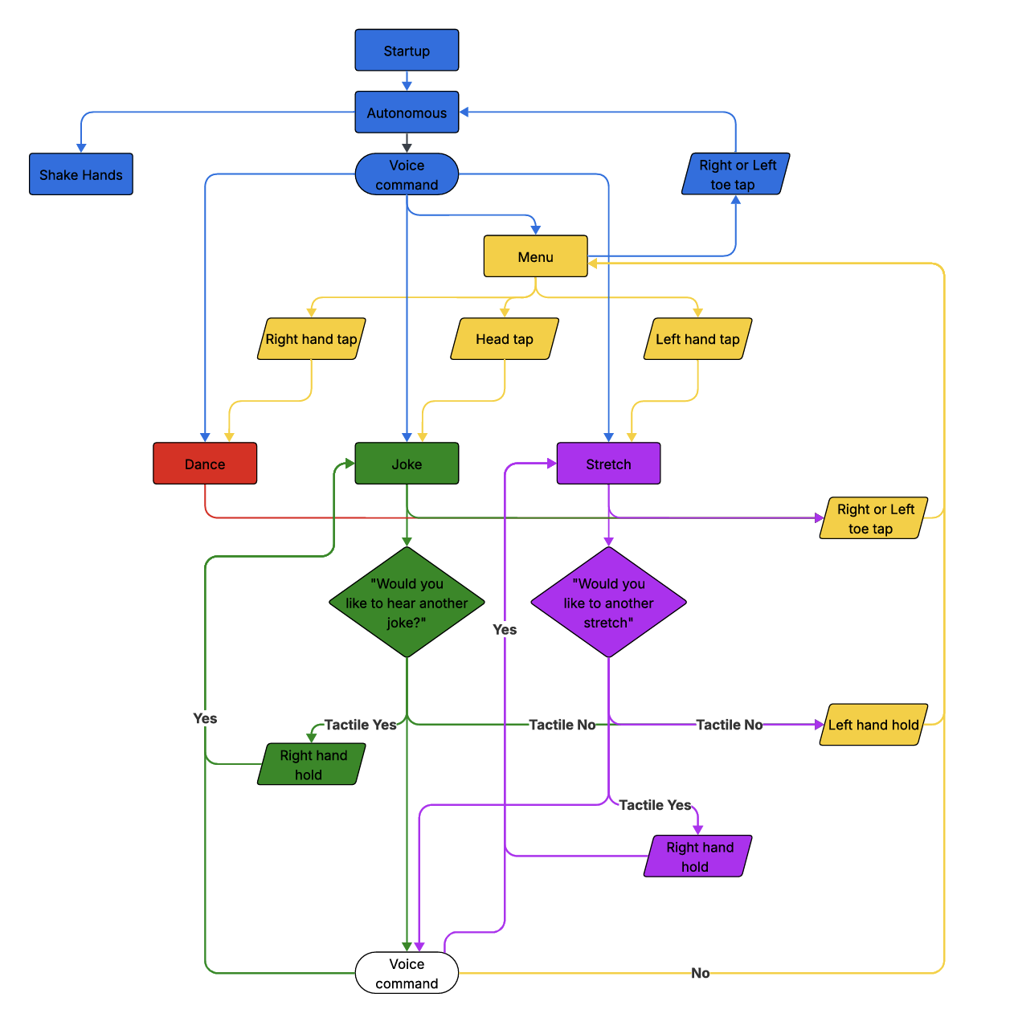
Figure 1 Flowchart for NAO behaviors

Instructions

Blue Section – Initialization and Core Control
🟦 The process begins at the Startup stage, where the NAO robot powers on and initializes all systems. It then enters the Autonomous mode, allowing it to independently recognize and respond to both tactile and voice inputs. In this mode, the robot can directly take voice commands to perform actions such as 🟥 Dance, 🟩 Joke, or 🟪 Stretch without requiring manual input.
If the user says the keyword “Menu,” the robot transitions into a selection interface where tactile gestures are used to choose activities: a Right Hand tap activates Dance, a Head tap triggers Joke, and a Left Hand tap starts the Stretch routine. This design enables both hands-free operation through speech and manual selection via tactile interaction, providing flexible user control.
Note: The system does not return directly to Voice Command after routines. All routines exit to the Menu first, and returning to Voice Command requires additional toe presses.

Yellow Section – Menu and Gesture Inputs
🟨 The Menu section is the central hub for physical interactions. It can be reached from a voice-triggered “Menu” command or from a toe-tap exit from any routine. Within this section, the robot responds to three tactile triggers: a Right Hand tap starts the Dance routine, a Head tap begins the Joke routine, and a Left Hand tap initiates the Stretch routine.
From this Menu state, the user may reach Voice Command only after additional toe presses, following the new multi-press exit rules.

Red Section – Dance Routine
🟥 The Dance routine is activated by a voice command or a Right Hand tap. During the dance, the user may use toe taps to interrupt the routine. When the dance finishes—or when interrupted—the robot returns to the Menu. From the Menu, additional toe presses are required to reach Voice Command.
Toe tap logic:
- 1 toe press → Menu
- 2 toe presses total → Voice Command

Green Section – Joke Routine
🟩 When the user triggers the Joke routine (by voice or Head tap), NAO tells a joke and then asks, “Would you like to hear another joke?” If the tactile response is Yes (through voice or a Right Hand hold), the robot loops back to the joke stage to tell another one. If the tactile response is No (Voice or Left Hand Hold), control returns to the Menu stage for a new instruction. This green segment captures the humor and dialogue interaction pathway. A Right or Left toe tap at this stage can also redirect the system to the Menu. Additional toe presses are required to reach Voice Command.

Purple Section – Stretch Routine
🟪 The Stretch routine begins either from a Left Hand tap or from Voice. After completing one stretch cycle, NAO asks, “Would you like to do another stretch?” A Yes response (Voice or Right Hand hold) restarts the stretching motion, while a No (Voice or Left Hand hold) response transitions control back to Menu. Additionally, a Right or Left toe tap at this stage can also redirect the system to the Voice Command, allowing users to easily switch tasks.

